EDU4BIB: Biology Teaching Method

Richard Fox
Student: 91008197

Task 2: ICT Resources for Biology Teaching
_________________________________________________________________________________

The adoption of Information and Communication Technology (ICT) in today’s classrooms is taking place at an ever-increasing pace. Teachers may be overwhelmed at the breadth and depth of resources available to education, needing to develop new skills in order to utilise these new tools to their best effect.

A beneficial effect of the growth of the ICT market is the greater affordability of the technology, bringing it within reach of educational budgets. Infrastructure, hardware and core software still require significant investment, but there is a great selection of free or inexpensive content on the internet that teachers can use to enrich and vary their teaching. The current generation, Prensky’s ‘digital natives’ (Prensky 2001), are exposed to forms of these technologies through most of their waking hours, so their education needs to reflect this. ICT helps support the shift from teacher-centred to student-centred learning, providing tools for student research, collaboration and creativity.

The science disciplines can benefit from use of ICT in teaching, when one considers that the technology is a product of our scientific endeavour. Whilst Biology began with observation of living organisms in vivo, ICT allows us to visualise the smallest virus or analyse complex systems such as the ecologies of the whole planet.

Here follows short reviews of five examples of ICT resources for use in a Biology classroom.

1. Douchy’s Biology Podcast

Type: podcast
Cost: free
URL: http://web.mac.com/andrewdouch/Site/Biology_Podcast.html
(or search for ‘Douchy’s Biology Podcast’ on iTunes)

Andrew Douch is a VCE Biology teacher at Wanganui Secondary School, Shepparton. He produces a podcast for VCE Unit 3 & 4. An obvious benefit of this is that the content is aligned with the Victorian curriculum. Delivery in an audio format may be of value for students who have difficulty in a normal classroom, e.g. learning styles, dyslexia, or students that cannot attend school due to illness or in remote learning. It allows any student to conveniently revise classroom material whilst commuting. The presenter has an engaging manner and students may be more receptive to content presented with an Australian accent and idiom. Taylor and Clark (2010) observed that, contrary to expectations, students showed a preference for their lecturer’s voice rather than a professional presenter, highlighting the connection between teacher and student. Typically podcasts are short segments (5 – 20 minutes) which easily fit into free study time, but this podcast runs to over an hour per episode. The benefit of this format over lectures or even traditional real-time broadcast is that the consumer determines when they use the content, and they can stop, review, or skip ahead as their personal needs dictate.

The podcast also invites phone-in or email questions from listeners, which are answered in the next instalment, and a short revision quiz.

Podcasting is cheap, easily accessible and attractive to the iPod generation. Often podcasts are simply recordings of lectures, so there is a possibility that some students will not attend classes if they know they can just download them afterwards. In this example, the podcast is a study aid intended to complement formal classes, not replace them. Another variation is to add images to illustrate key points of the podcast, creating a narrated slideshow presentation. Video podcasting, or ‘vodcasting’ is also popular, but requires more production work, creates bigger files and does not lend itself to use whilst commuting.

Relatively few studies of the effectiveness of podcasting technology for learning in K-12 education have been done (Putman and Kingsley 2009), there being more research related to tertiary education.

2. Blind Watchmaker

Type: simulation
Cost: free
URL: http://www.phy.syr.edu/courses/mirror/biomorph/

This simulation is a derivation of Richard Dawkins’ original Blind Watchmaker computer program. The software algorithm creates generations of ‘biomorphs’ - geometric figures, according to random variations in any of 15 ‘genes’ that control different traits of the biomorph, including colour, size, shape and structure. Over time, complex patterns appear and mutate into new forms.

The algorithm was described in Dawkins’ book of the same name, which is a refutation of the creationist argument that complex organisms could not have evolved from simpler life forms by random variation. (Dawkins 1986).

This resource would be a good introduction to VCE Unit 4 – Area of Study 2, ‘Change over time’. One could either direct the students to try it out for themselves, or it could be used a class activity, projecting on a screen and inviting students to choose the parent for each generation, and discussing the changes produced.

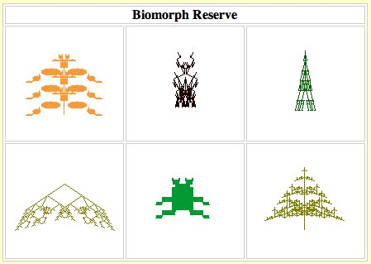
Examples of biomorph patterns created by the simulation

The software is a Java applet that runs in the web browser. The teacher may need to explain that nothing seems to be happening for the first 20 generations or so, until the first single-celled biomorphs appear.

3. DNA Interactive – Recovering the Romanovs

Type: web application
Cost: free
URL: http://www.dnai.org (Follow the ‘Applications’ link)

This resource is a module hosted on the DNA Interactive site, affiliated with the Cold Spring Harbor Laboratory. The module describes the scientific investigation of the disappearance of the last Tsar and his family during the Russian Revolution. The authors have skilfully blended genetics, forensic science and 20th century history into an interesting narrative that may be engaging for students who would not normally be interested in science. The text is well illustrated with photographs and includes some interactive exercises.

The resource could be used in a unit on genetics or one on forensic science. The online format means that it could either be used in class time or set as homework. The self-paced style allows for students learning at different rates.

The resource is well-designed and easy to navigate. It loads quickly and uses the Flash animation format.
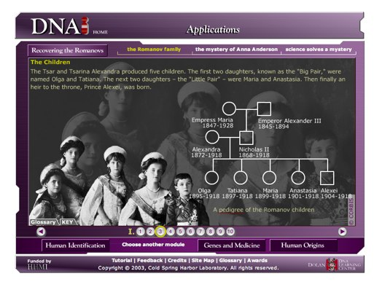
The remainder of the DNA Interactive web site contains numerous useful resources worthy of examination.

4. PASCO SPARKvue

Type: data logging system
Cost: expensive
URL: http://www.pasco.com

The SPARKvue device is a portable computing device designed for use in science education. It interfaces with an extensive range of sensors allowing it to be configured for numerous measurements in scientific experiments. Because the device is designed for education, the manufacturers have taken into account the environments that the device will be used in, so it is designed to be portable, robust and appealing to young students. Students that are not comfortable with computers may prefer such devices. The dedicated design means that it easier to keep students on task by removing distractions such as social networking, and the closed system means that the device is less vulnerable to technical faults and hacking.

The peripherals use a proprietary interface preventing interoperation with other manufacturers’ systems, but they are also usable with conventional computers through an adaptor, so a school could use a mix of these devices alongside computers with the same sensors. The decision comes down to how a school chooses to spend their budget; if they have adequate computer resources they may just buy the sensors.

The downside of the closed system design is that the devices are not as versatile as a computer. For the cost of the devices, one can buy an inexpensive PC which can be used for other tasks e.g. internet access, word processing.

One pitfall with buying proprietary technology is that when the technology changes you are left with devices that are now obsolete. Many schools will have a collection of sensors compatible with the old PC serial port standard, which has been abandoned in favour of the USB standard. Similarly, as new operating systems arrive the vendor may not update software drivers. PASCO is a major player in this market so one could assume that their systems will be current for a reasonable period of time.

Use of data-logging technology can have benefits in reducing time spent taking measurements, allowing students to concentrate more on science content learning (Kelleher 2000).

The hardware devices are well supported with software modules written for particular practical exercises, lesson plans and workbooks. This may make be attractive to a teacher who does not know the content well, or does not wish to invest time in lesson planning, but they would need to be sure that the provided material integrated with the curriculum they are following.

5. Life Science: Human Homeostasis

Type: simulation
Cost: free (requires Learning Federation access)
URL: http://www.scootle.edu.au Resource L8998

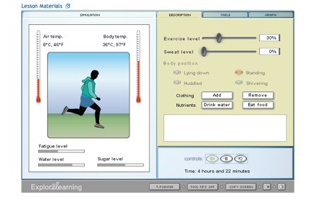
This resource provides a simulation of homeostasis in the human body. Students are able to observe the effects of changing external and internal variables on internal body temperature, including exercise, perspiration and clothing levels. A human figure and thermometers give visual feedback, and the resultant data can be tabulated, graphed or exported.

The resource includes a lesson plan with support materials in the form of a worksheet, a vocabulary sheet, and a teacher guide. I would find it useful for explaining homeostasis in VCE or National Curriculum Unit 3, especially as this is a topic that does not lend itself to practical experiments due to ethics considerations.

As with all Learning Federation objects, it is intended for download by the teacher for loading onto a school intranet, but this resource links to external content provided by a third party. A teacher may require some technical support to download the resource and place it on a school intranet. The resource requires Adobe’s Shockwave player software, which is a free download but needs to be installed on the client computers.

References

Dawkins, R. (1986). The blind watchmaker. London, Longman.

Kelleher, R. (2000) A review of recent developments in the information communication technologies ICT) in science classrooms. Australian Science Teachers Journal, Mar 2000, 46(1). pp. 33-38.

Prensky, M. (2001). Digital immigrants, digital natives. On the Horizon, 9(5), October 2001 Retrieved from http://www.marcprensky.com/writing/Prensky%20-%20Digital%20Natives,%20Digital%20Immigrants%20-%20Part1.pdf

Putman, S. M., Kingsley, T. (2009). The Atoms Family: Using Podcasts to Enhance the Development of Science Vocabulary. The Reading Teacher, 63(2). pp. 100-108. doi:10.1598/RT.63.2.1 Retrieved from http://pdf10.ggimg.com/imgdoc/A21014100934.pdf

Taylor, L., Clark, S. (2010) Educational design of short, audio-only podcasts: The teacher and student experience. Australasian Journal of Educational Technology, 26(3). pp. 386-399 Retrieved from http://www.ascilite.org.au/ajet/ajet26/taylor.pdf

